**Setting**

1. Artist Information – Taylor Swift

Taylor Swift start as a country music singer who is in the music industry for 18 years now. She began her career in 2006 with her first album called “Taylor Swift”. Since then she evolved into one of the most prominent figures in music, transitioning from country to pop. Currently, she has been experimenting with indie and alternative genres.

Throughout her career, Taylor Swift has released 11 studio albums ang 4 re-recorded albums (Forbes, 2024). The total number of tracks that she published a total of 274 tracks after the addition of her latest album (Newsweek, 2024).

*References*

Toni FItzgerald. (2024). *Taylor Swift albums*. Forbes. <https://www.forbes.com/sites/entertainment/article/taylor-swift-albums/>

Sophie Lloyd. (2024). *How Many Albums Does Taylor Swift Have? Timeline of Song Releases. Newsweek*. [https://www.newsweek.com/taylor-swift-how-many-albums-songs-tortured-poets-anthology-1892216 - :~:text=On%20Friday%20morning%2C%20Swift%20announced,number%20of%20tracks%20to%20274.](https://www.newsweek.com/taylor-swift-how-many-albums-songs-tortured-poets-anthology-1892216#:~:text=On%20Friday%20morning%2C%20Swift%20announced,number%20of%20tracks%20to%20274.)

**Data Selection and Exploration**

1. Collection of Data

Reddit was chosen as the platform for data collection as the sentiments of the redditors are more related to the thread that was chosen compared to the comment sections in Youtube in the search strategy that was applied. The search strategy only chose the top threads related to the most recent 4 albums released by Taylor Swift including the re-released versions. It should also be noted that showbiz related feud and political thread was ignored to only focus on the improvement of the musical aspect of the artist. They key search words that gave the desired results and the chosen links are:

Search Words:

* Taylor Swift Latest Album
* Taylor Swift Midnights
* Taylor Swift Version
* Taylor Swift Album Megathread

Links:

* <https://www.reddit.com/r/TaylorSwift/comments/y9ivjo/midnights_megathread/>
* <https://www.reddit.com/r/TaylorSwift/comments/17he0ir/1989_taylors_version_megathread/>
* <https://www.reddit.com/r/TaylorSwift/comments/1aj5rqq/the_tortured_poets_department_album_announcement/>
* <https://www.reddit.com/r/TaylorSwift/comments/139b5nl/speak_now_taylors_version_announcement_megathread/>

The number of data points collected are in total of 3366.

*Figure 1. Data Points*

1. Top 5 Influential Actors

The dataset was removed of any rows that contains a null attribute and was then created into a network graph resulting into these 5 influential actors. The result also shows that people are more interactive to the comments of aran130711, PassionateAsSin and Lyd_Euh. Furthermore, there is a tendency that [deleted] is a false result as the activities of multiple deleted accounts in reddit can fall into the category of the [deleted] account.

*Figure 2. Top 5 influential actors*

*Figure 3. Actor Network Graph visualization*

The reason there are only 3 prominent figures in the visualization is because the gap between the pagerank of the top 3 results compared to the top 4 and top 5.

1. Unique Actors in the dataset.

There are around 1481 unique actors in the actor graph and was obtained by using the length function of R. This will return the number of unique actors which was converted into row in the actor network graph.

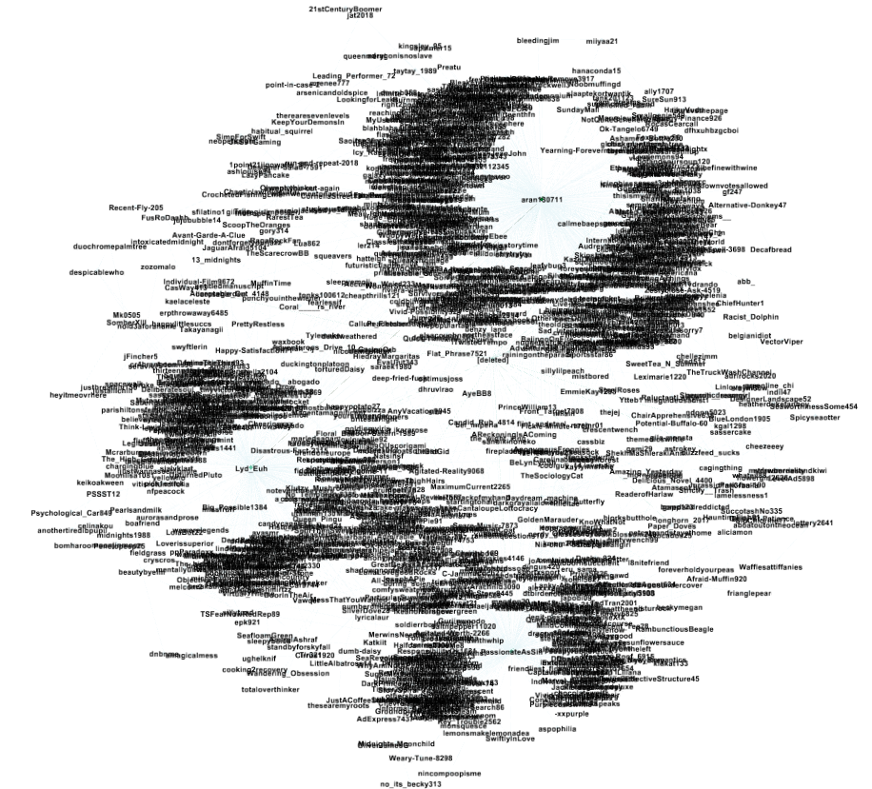

*Figure 4. Unique Actors Network Graph visualization*

1. Spotify Data

Active Years

The data collection in spotify for Taylor Swift showed that spotify has the oldest album released in 2014 where as in the searched in part 1 there are albums dating older than 2014. This is probably due to an issue back in 2014 which is not related to the case study.

*Figure 5. Taylor Swift albums in spotify*

Albums and Songs Published

The data collection showed a result of 20 albums released in Spotify and 359 songs published by Taylor Swift. These figures were obtained by searching for albums related to Taylor Swift and looping through each album to create a data set of all_tracks.

*Figure 6a. album and tracks code*



*Figure 6n. album and tracks count*

The underlying reason for this result is that there are albums which have different versions such as the folklore having a deluxe edition.



*Figure 7. folklore album with different versions.*

Collaborators

Collaborators in the Spotify data were obtained by unnesting the artist column of each album. The resulting artist was then filtered to remove the “Taylor Swift”artist_name to only display the list of artists that Taylor Swift did a collaboration with. Figure 8a shows the code to unnest and filter the collaborators and figure 8b shows the list of collaborators.

*Figure 8a. extracting collaborators*

*Figure 8b. List of Collaborators*

Prevalent Features

The noticeable features in Taylor Swift’s tracks are the valence and danceability. These attributes can be compared as they behave in a proportional manner where if the valence is high (which means the song is positive), the more it is danceable.

From the results in these attributes, it can also be inferred that the lesser valued tracks in terms of valence and danceability are those songs that relates to heartbreak or nostalgia. Taylor Swift’s evolution to pop music can also be observed as some of her songs has a high danceability and valence.

*Figure 9a. audio features code*

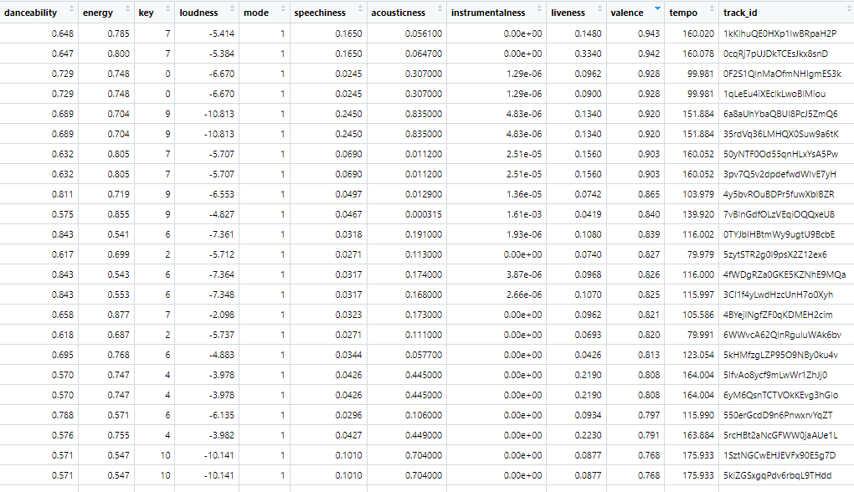

*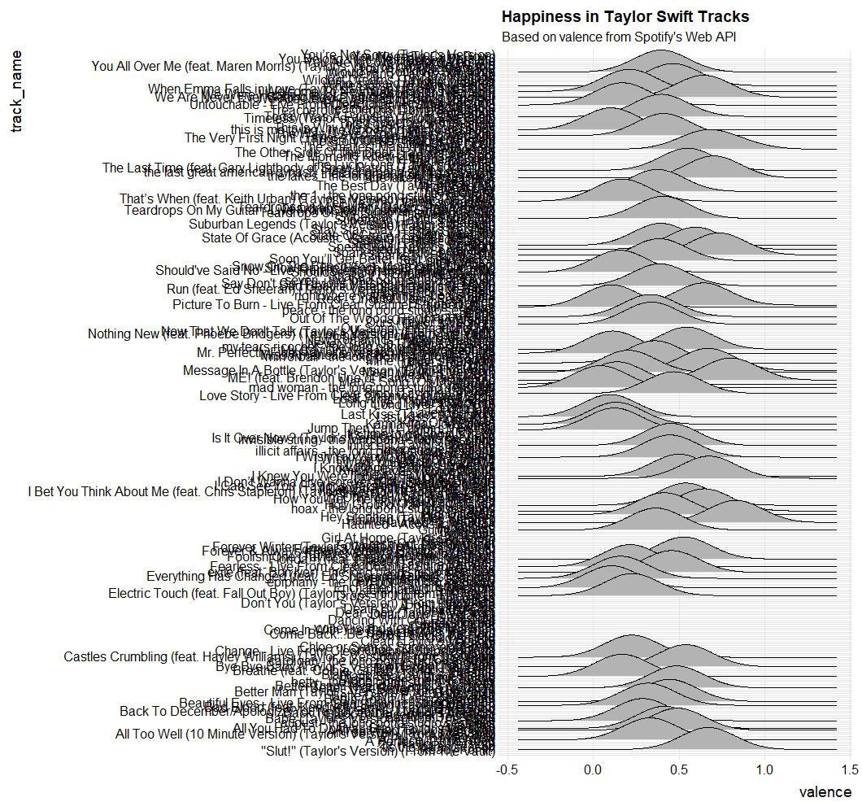Figure 9b. audio features result*

*Figure 9c. valence per track graph*

*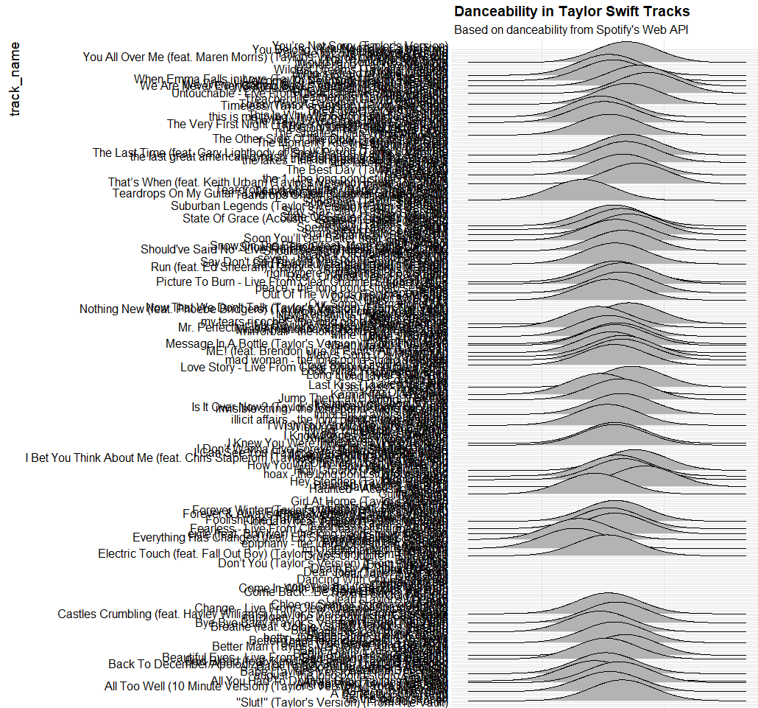Figure 9d. danceability per track graph*

**Text Pre-processing**

1. Term-Document Matrix

The top 10 meaningful terms were achieved by removing unnecessary terms, converting each word to stem words, and removing stop words. The results are as follows:

Album – The highest reoccurring word; High probability because the threads search was about taylor swift’s most recent album.

Song – One of the main items expected to find in a data collection for a singer. The main target is the sentiment of the users for the songs of Taylor Swift

Taylor – The first name of the artist.

Love – These term could either people use the term “love” to describe their sentiment to the tracks or is about how Taylor Swift’s music is mostly about love songs.

Feel – This is expected in a love song. This could be part of the statement where people describe how they are feeling towards the album

Sound – By product of the song, or is used by the users to describe the song sounding like something familiar to them.

Listen – The verb users do in order to feel something from the track.

Track – This is another word for song or recording.

Version – Two of Taylor Swift’s latest album are re-released version; hence versions of the album was discussed.

Time – This term could be related to how to users feel after Taylor’s re-release of the album which happened years before.

*Figure 10a. Top terms used*

*Figure 10b. Visualization for top 10 frequent words*

1. Semantic Networks

By obtaining the bigrams or the consecutive pair of words often appearing are obtained by using the functions in R. It was then sorted according to page rank which returned a result of the top 10 important words from the thread related to Taylor Swift. Those word are as follows:

*Figure 11a. Top 10 most important words according to page rank*

It could be observed that the top term “album” has more then double the occurrence compared to the rest of the terms in the top 10 result. This could be due to the main topic of the subreddit to be the most recent album’s of Taylor Swift. There are 2 results that hold the same meaning such as taylor and taylors where taylor could be when the users are talking about the artist “Taylor Swift” while taylors could be the stem word for the terms taylor’s version, as there are two albums related to the thread that are taylor’s version release. The rest of the terms are music entertainment related and genre related such as pop, tv, songs and favorite. The last term is the profanity which is “fucking” which are also A network of dots and lines
often used by the users as an expression.

*Figure 11b. Top 10 most important words visualization*

**Social Network Analysis**

1. Centrality Analysis

The centrality analysis were performed to different datasets belonging to the main artists and two related artists.

1. Taylor Swift

Centrality analysis was performed to the actor network graph previously created to show the scores and determine if it is relevant to the artist. The related artist are obtained by the related artist function of the spotifyr.

Degree Centrality – The degree centrality measures the number of direct connections a user has. In this case, it would show the number of replies or comment the user has given out or received. The first sorting shows the aran130711’s thread received the most replies whereas the [deleted] user comment the most. This may also be a false data, as the score [deleted] user received where an accumulation of the multiple deleted accounts that commented in the thread. The total sorted shows the total (in and out) activity the user has done or received.

*Figure 12a. Sorted degree centrality results*

Closeness Centrality – This measure how each of the users are close to the rest of the discussion. This could mean that user may have reached out to more user via the reply they posted. The values shown in the results shows that most users have the same closeness score which means most users can be reached by other users on an equal level and vice versa.

*Figure 12b. Sorted closeness centrality results*

Betweenness Centrality – This would indicate that these users posts are the most often nodes the appear on the shortest paths between other nodes. The result is also a bit reasonable as the degree centrality of aran130711 was the highest, hence this user’s reply has the most interaction in the thread. Most of the results in the betweenness could be seen in the previous centrality analysis done.



*Figure 12c. Sorted betweenness centrality results*

Relevance of Results – The relevance of the centrality analysis for Taylor Swift is through the revelation of how the users contribute to the topic of her albums and activities. It can also be shown that some users which in this case are fans of Taylor Swift, are relevant to increase her popularity by engaging with fellow users especially in the digital and information age we are in. The users with high centrality tend to drive the narrative that revolves around Taylor Swift and build different discussions which may in turn affect the sentiments other fans have for Taylo Swift.

*Figure 12d. Actor Graph Network Taylor Swift*

1. Olivia Rodrigo Centrality Scores

The component size of Olivia Rodrigo’s search threads are up to 659. This would mean that there would be a gap in the centrality scores when comparing Olivia Rodrigo’s to Taylor Swift’s.

*Figure 12e. Component Size Olivia Rodrigo*

Degree Centrality – The fairly noticeable as only one person in this subreddit received a reply of more than a 100, the rest only falls up to a range of 50. This would mean that the subreddit was mostly affected by a single significant person which is “NominalPerson”.

*Figure 12f. Sorted degree centrality results Olivia Rodrigo*

Closeness Centrality – The result is still somewhat similar compared to Taylor Swift’s result. This is because how the thread system is structured where it is easy for people to connect to another hence the closeness centrality of all users are fairly even.

*Figure 12g. Sorted closeness centrality results Olivia Rodrigo*

Betweenness Centrality – With a huge difference in community size, it can be observed in the betweenness centrality results. This is because since there are fewer edges, there is a direct proportionality to the difference in number of routes.

*Figure 12h. Sorted betweenness centrality results Olivia Rodrigo*

the difference in number of routes.

*Figure 12i. actor network Olivia Rodrigo*

1. Ariana Grande Centrality Scores

Having a component size of only 160, it can be seen the drastic difference between the centrality scores of the actor graph in Taylor Swift’s centrality analysis compared to Ariana Grande’s analysis.

*Figure 12j. Component Size Ariana Grande*

Degree Centrality – The difference in degree centrality compared to Taylor Swift is rather noticeable. Although, it can also be observed that the distribution among the activities per user is more even compared to Taylor Swift’s where only 4-5 users received more than 10 replies where as here, it can be seen that all of the top 10 users received replies of more than 15.

*Figure 12k. Sorted degree centrality results Ariana Grande*

Closeness Centrality – The result is similar with Taylor Swift’s results. This could mean that the structure of the thread system of Reddit also plays a role on how the users are close to other users.

*Figure 12l. Sorted closeness centrality results Ariana Grande*

Betweenness Centrality – With a huge difference in community size, it can be observed in the betweenness centrality results. This is because since there are fewer edges, there is a direct proportionality to



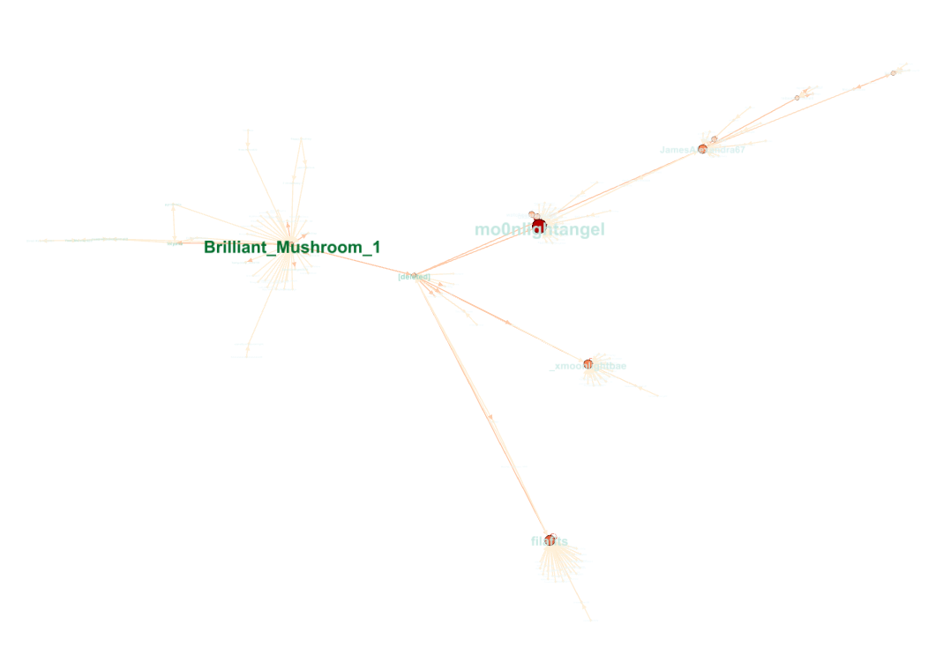*Figure 12m. Sorted degree centrality results Ariana Grande*

*Figure 12n. actor network Ariana Grande*

1. Girvan-Newman and Louvain methods
2. Taylor Swift

Louvain Algorithm – The modularity-based algorithm that helps us identifies communities which have dense links within the clusters. The relevance would be knowing which communities in the data sets are more active in this case Is the community number 7. Furthermore, we could also identify the user groups, in the community and see how their conversation develop to further promote Taylor Swift’s popularity.

*Figure 13a. Louvain algorithm result.*

*Figure 13b. Louvain modularity class visualization*

Girvan-Newman – This algorithm has the same goal but has a different approach where it progressively removes edges with the highest betweness centrality, to split the network to smaller subgroups hence identifying the communities. This algorithm has a relatively similar result with the Louvain algorithm only having a difference on a minimal amount of users in a community.

*Figure 13c. girvan-newman algorithm result.*

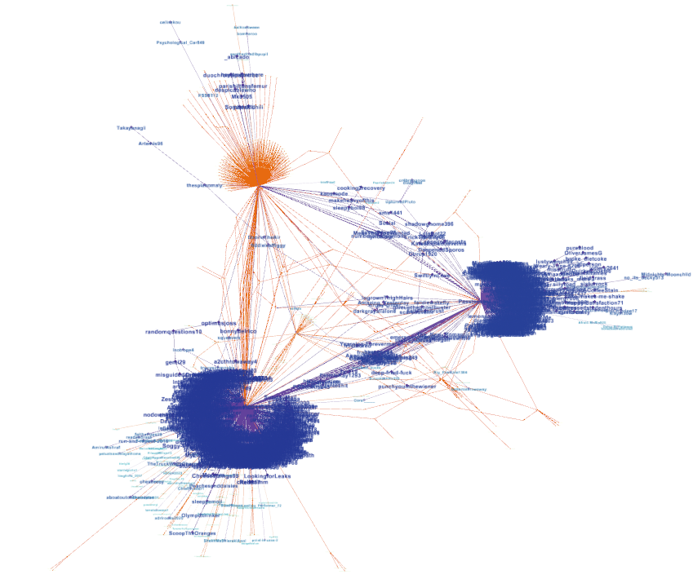

*Figure 13d. girvan-newman algorithm visualization.*

Relevance – Overall these algorithms are important in order to have a sub-topic exploration and also observe user engagement patterns. Both of these aspects will be a vital information to find a way to further promote Taylor Swift’s positive semantic response by the public,

1. Olivia Rodrigo

In general, Olivia Rodrigo’s threads demonstrated a different structure in community analysis, as the distribution of activity only falls mostly in one community comparing to Taylor Swift’s 3 major communities.

Louvain Algorithm – The community size in Olivia Rodrigo compared to Taylor swift is far lesser and there is only one community that reached more than a hundred of interactions among users.

*Figure 13e. louvain algorithm results olivia rodrigo.*

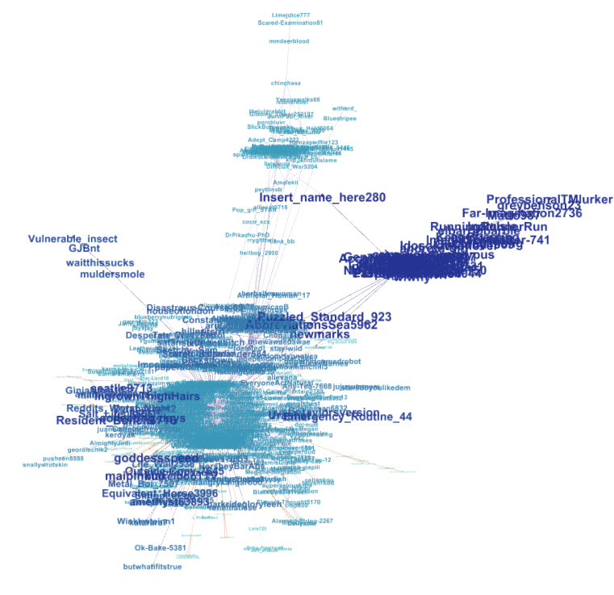 *Figure 13f. louvain algorithm visualization olivia rodrigo.*

Girvan-Newman – This algorithm shared a similar result with it’s Louvain counter part. Comparing to Taylor Swift’s results, given that there are fewer users in the threads, it is also expected that these algorithm will show a far lesser results.

*Figure 13g. girvan-newman algorithm results olivia rodrigo.*

*Figure 13h. girvan-newman algorithm visualization olivia rodrigo.*

1. Ariana Grande

In general, the huge difference of users active in Ariana’s threads compared to Taylor Swift resulted in a far lesser community generated. It can also be observed that in the communities are fairly distributed among each users.

*Figure 13i. louvain algorithm results ariana grande.*

*Figure 13k. louvain algorithm visualization ariana grande.*

Girvan-Newman

*Figure 13k. girvan-newman algorithm results ariana grande.*

*Figure 13l. girvan-newman algorithm visualization ariana grande.*

**Machine Learning Models**

1. Sentiment Analysis